**Contents**

**INTRODUCTION** 1

**TEAM MEMBERS** 2

**ROLES** 2

**GANTT CHART** 3

**GLIMPSE ABOUT APP** 4

**What is Agile Methodology?** 4

**PAGES AND SCREENSHOTS** 5

HOME PAGE 5

Category Sections Page 5

Product Sections Page 6

Other Screenshots 7

## **INTRODUCTION**

The main aim of this project is the design of an agile / scrum mobile application named SaleSharks. It is related to the sales app which is used for having all records of any product ,whosever buy the product .

# **TEAM MEMBERS**

1.Sukhmanpreet Singh Romana

2.Gurlal Singh

3.Shivam Sharma

4.Yogesh Malik

5.Sukhpal Singh

## **ROLES**

Gurlal Singh : Product Owner

Yogesh Malik : Scrum Master

Sukhmanpreet Singh Romana : Front End Developer

Shivam Sharma : Stakeholder

Sukhpal Singh : Back End Developer

## **GANTT CHART**

|  |  |  |  |  |  |  |  |  |  |  |  |  |  |  |  |
| --- | --- | --- | --- | --- | --- | --- | --- | --- | --- | --- | --- | --- | --- | --- | --- |
| **Stages** | **Activities** | **Duration**  **Week1-2** | | | | **Duration**  **Week-2-3** | | | | | **Duration**  **Week-3-4** | | | | |
| Project Planning | Research |  |  |  |  |  |  |  |  |  |  |  |  |  |  |
| Start of Meeting |  |  |  |  |  |  |  |  |  |  |  |  |  |  |
| Project Proposal and documentation |  |  |  |  |  |  |  |  |  |  |  |  |  |  |
| Project Execution | Application Design |  |  |  |  |  |  |  |  |  |  |  |  |  |  |
| UI Design |  |  |  |  |  |  |  |  |  |  |  |  |  |  |
| coding |  |  |  |  |  |  |  |  |  |  |  |  |  |  |
| Testing |  |  |  |  |  |  |  |  |  |  |  |  |  |  |
| Final | Documentation and Report |  |  |  |  |  |  |  |  |  |  |  |  |  |  |

0 1 2 3 4

## **GLIMPSE ABOUT APP**

This app is a sales app which is used for having all records of any product ,whosever buy the product his/her name .Moreover, there are prices included .

It took about 4 weeks to complete the application.

This app has three sections :

1.Category Section

2.Product Section

3.Sale Section

There are also other buttons in every section such as Edit, Delete or view product .

## **What is Agile Methodology?**

The Agile methodology is used in this project as an alternative to traditional approaches. This strategic approach is highly effective and pragmatic and addresses technology's changing needs.

Our group used the agile / scrum method in this project. The team members originally identify and follow all requirements. The team then decided to implement the SaleSharks App to satisfy users ' needs.

There have been many changes to make this software more user-friendly. The app is available for customers after all updates have been created.

## **PAGES AND SCREENSHOTS**

## HOME PAGE

This is the main page of the application. On this page there are three buttons Category Section, Product Section and Sale Section . With the help of this page, the user can select the option as per their choice.

## Category Sections Page

In this page, there are five buttons named as ADD NEW CATEGORY, VIEW ALL CATEGORY, EDIT CATEGORY,DELETE CATEGORY AND BACK TO MAIN .

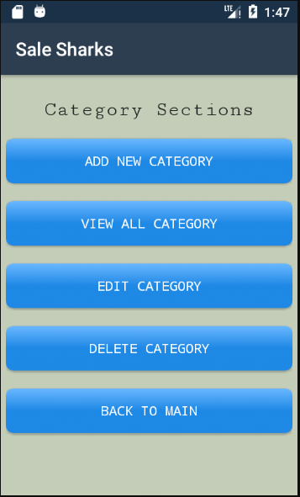

## Product Sections Page

In this page, there are also five buttons named as ADD NEW PRODUCT, VIEW ALL PRODUCT, EDIT PRODUCT,DELETE PRODUCT AND BACK TO MAIN .

## Other Screenshots

